**Bakerz bite**

*User guide*

|  |  |  |
| --- | --- | --- |
| **Supervisor** | Sir Azhar | |
| **batch** | 2210e | |
| **group** | Bakerz bite | |
| *Serial*  *no.* | *Enrollment*  *No.* | *Student*  *name* |
| *1.* | 1424642 | javeria |
| *2.* | 1424891 | Farwa |
| *3.* | 1423740 | *Aqsa* |
| *4.* | 1432145 | *Vinesh* |

|  |
| --- |
| **USER GUIDE** |

“Bakers Bite” This Website is basically based on fresh cookies, cakes cupcakes donuts and its delicious flavor. If you are passionate about cakes, donuts, cupcakes, cookies, so just this website made for you.

1. **TOP LAYOUT**

**This is the Top of the page.**

* **User can know about the website by clicking on About Us**

**button**

* **Users can get touch to the admin by Registering their selves**

**from this page.**



1. **Home Page**

This page contain our special items & Some Bakery items

and their details.

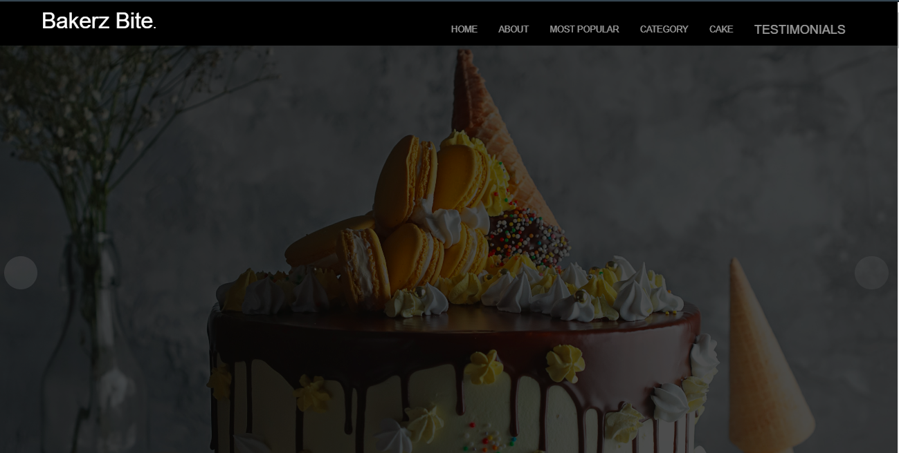

**3. Shop Page**

This is the Shop Page.

In this page users can grab their favourite Bakery items.

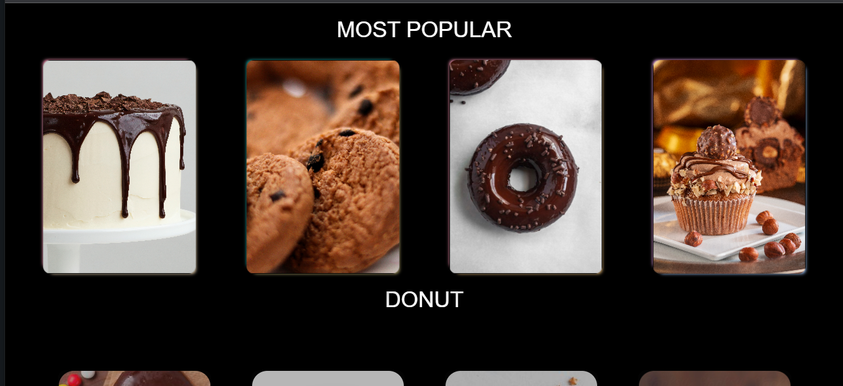

**4. Contact Page**

This is the Contact Page.

In this page users can get in touch with us.

They can leave their comment.

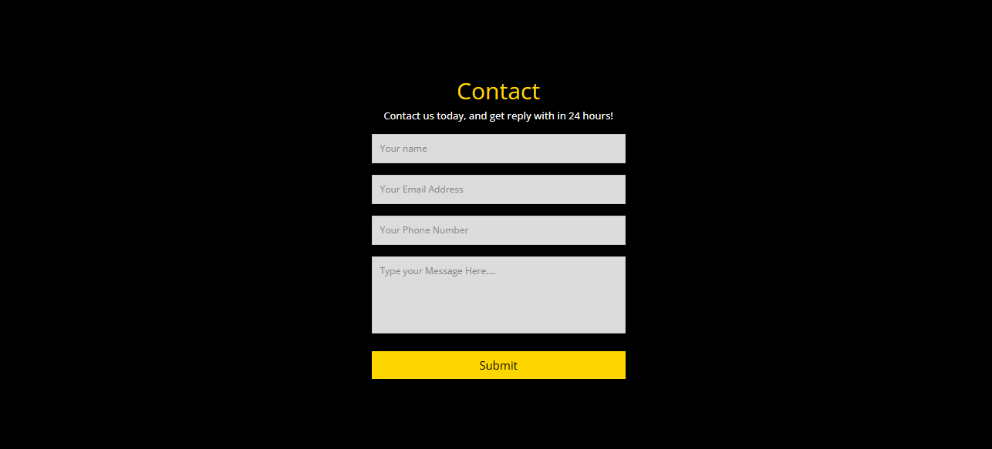

**5. About Page**

This is the About Us Page.

This page has some Information about our shop.

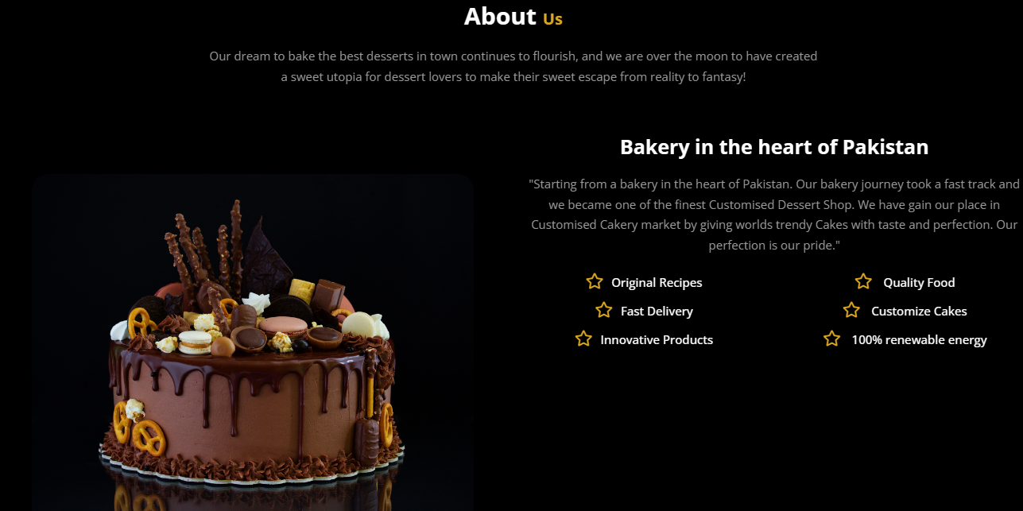

**7. Bottom Layout**

This is the Bottom of the page.

It has some Links like Shop Page , Contact Page and Our

Specialities.

It has some Popular Recipes link as well as some Official

Pages links.

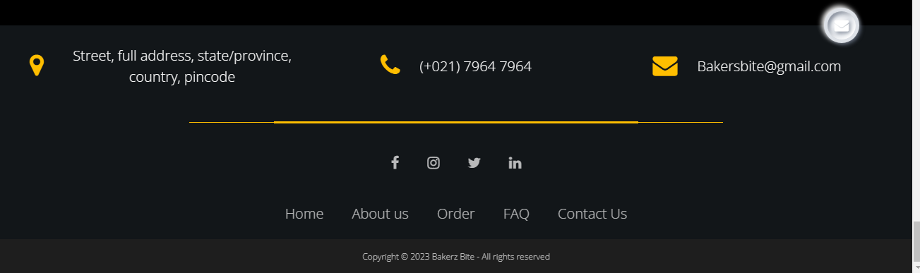

**Thank You For Reading The**

**Documentation.**